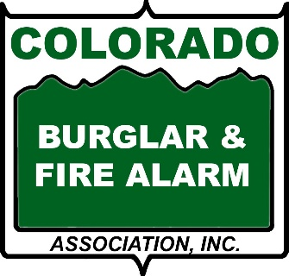
CONSUMER BEWARE
The business of selling residential alarm systems is very competitive and customers are aggressively sought by many companies through a variety of methods and means. There is a difference between good salesmanship and fraud, and you need to be aware of the difference. Those who are preyed upon are often the elderly, non-English speakers and those who have recently purchased a home.
All CBFAA member companies must adhere to a strict Code of Ethics and Standards of Conduct to ensure high quality work and services. Some examples are:
- Carry photo identification and clearly state who they work for when making sales calls
- Be properly licensed and registered in compliance with all applicable laws, ordinances and regulations.
- Members shall use written materials that clearly and conspicuously disclose all material terms and conditions of the offer before obtaining a customer's consent,
- Immediately discontinue a sales presentation and leave the premises if a potential customer asks them to leave,
- Never make any false statements about competing organizations.
FOR YOUR SAFETY
Be cautious of any UNSOLICITED sales contact. Verify all information before you authorize any new work or changes.
By capitalizing on large numbers of college students seeking summer employment, out-of-state unlicensed alarm companies often send teams of salespeople to cities. Most teams work on commission, incentives and contests. As they speak to homeowners they keep the pressure on in order make the sale. While licensed alarm representatives will complete the process ethically and responsibly, these representatives will not. ​
Common Scam: The Double Billing Scam
The fraud scheme goes like this: You receive an unsolicited telephone call or a knock on your door. This person tells you they now have ownership of your alarm system(s) or have taken over your account.
The salesman starts making false statements similar to the following; your current alarm company has been sold, is going out of business, is going into bankruptcy, or we have obtained all rights to your account. The salesman will want to change the programming for your alarm system and update your paperwork by writing a new contract with their company.
No legitimate alarm company will show up at your door to fix or replace equipment without a prior appointment having been made. If you are approached in this manner DO NOT ALLOW ANYONE ACCESS TO YOUR HOME OR BUSINESS. GET VERIFICATION FROM YOUR CURRENT ALARM COMPANY.
Take the time to make a phone call. You're still under contract with the current alarm company and a new contract may obligate you to a second alarm company and their charges. Without due diligence, you will start getting bills from both alarm companies.
This becomes the "Double Billing" scam. You often are left paying both bills, costing hundreds of dollars. Alarm businesses generally notify you, in writing, when they are being sold, transferred or having billing changes.

