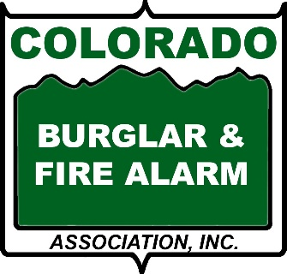

Helpful Resources for Consumers
Better Business Bureau
www.bbb.org
Colorado Attorney General – Consumer Protection
https://coag.gov/office-sections/consumer-protection/

Colorado Division of Homeland Security & Emergency Management
https://dhsem.colorado.gov/
Crime Stoppers - Metro Denver
www.metrodenvercrimestoppers.com​
Crime Stoppers - Northern Colorado
Contact your local police department to reach Crime Stoppers of Northern Colorado

Crime Stoppers - Pikes Peak Region – El Paso and Teller Counties in Colorado
www.crimestop.net

CyberSecurity & Infrastructure Security Agency (CISA)
www.cisa.gov

ESA - consumer website
Electronic Security Association
www.alarm.org
FBI – Denver
www.fbi.gov

NCPC
National Crime Prevention Council
www.ncpc.org

