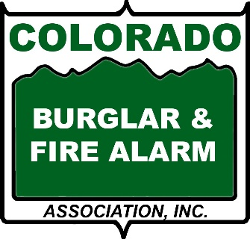

WHY DO YOU NEED A SECURITY SYSTEM?
- All too often homeowners and business owners are reactive when it comes to home security: they install a security system after their home or business has been invaded. It is important to be proactive.
- According to a study by University of North Carolina at Charlotte, approximately 83 percent of convicted burglars said they would attempt to determine if a security system was present before attempting a burglary. But simply sticking an alarm company’s sign in your front yard won’t be enough to convince burglars that your home is protected. Experienced burglars have several ways of determining whether a home is equipped with a security system.
- According to the FBI burglaries of residential properties accounted for 69.5 percent of all burglary offenses
- Studies show that burglars typically spend no more than one minute breaking into a home and fewer than 10 minutes inside. Although they work quickly, burglars have a keen eye for valuable possessions. The FBI reports that each home burglary victim suffers an average of $2,361 in property loss. For a list of top items burglars steal click here.
- Your chances of a break-in are highest right after you move into a new home - Burglars know that most people don't install security systems until 2 to 4 years after they move in.
- Burglars are more likely to break in to your home between 9:30 a.m. and 4:00 p.m., while you are at work, as opposed to breaking-in at night. For businesses, nighttime burglaries occur more frequently.
- Nearly half of burglars break-into homes through the front door, 32% choose the back door and 22% through a first-floor window. The rest break-in through a basement, garage or second floor window.
- Today's systems can not only detect invasion but also fire, gas leaks or environmental changes.
- Security is a critical component of smart home technology. Enhanced home security systems have user-friendly design and convenient lifestyle-enriching benefits such as remote monitoring and controls.
INSURANCE SAVINGS
Check with your homeowners/business insurance company! Typically, they offer a discount between 2% and 20% on your insurance when you install a security system. Click here for more details about insurance companies and alarms.

